Functions: print, type, input

Conversion function: int, str, float

Basic data types: int, float, str (single, double or triple ‘ “)

Precedence of operators: arithmetic > relational > logical 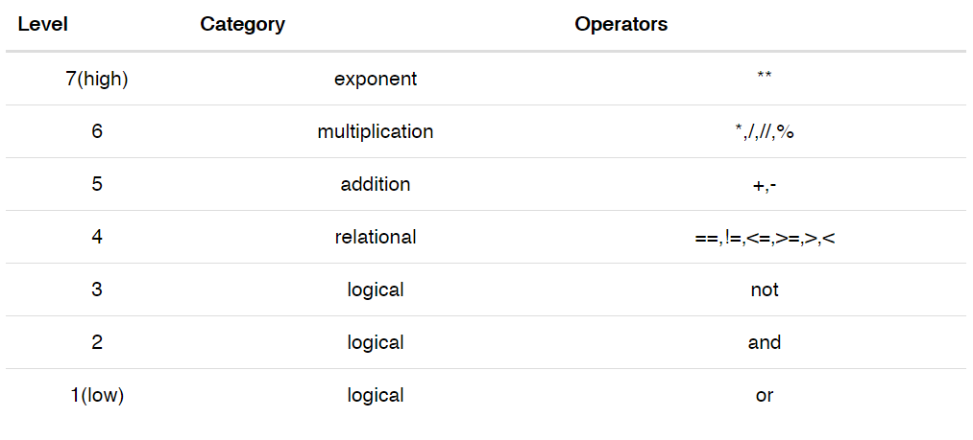

Variables

* To assign an object to a variable
* To give meaning to data/object
* To store/reuse data

User-defined data types

* Define (class ___name____:)
* Create (instantiation)

Flowchart

* Sequential/branched
* Iterations/loop

Errors

* Syntax: structure of a program and rules about the structure are not adhered to
* Runtime: error that don’t appear until you run the program (exceptional)
* Semantic: run successfully, but it does not do the right thing as intended

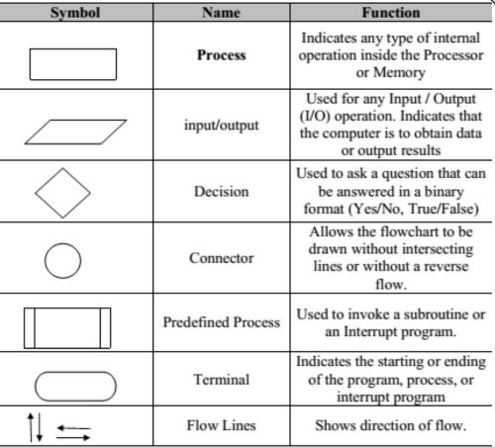

Miscellaneous

* Dot operators (to access the attribute)
* , tuple
* Program counter (codelens)

PCDIT

* Problem statement (i/o, process/computation)
* Cases
* Design
* Implementation
* Testing